Project Design Phase-II
Data Flow Diagram & User Stories

Date | 17-12-2025
Team ID
Project Name | Video Conferencing App
Maximum Marks | 4 Marks

Data Flow Diagrams:
A Data Flow Diagram (DFD) illustrates how data moves within the Video Conferencing App. It represents how different users (hosts, participants, and admins) interact with the system, how data flows between frontend, backend, and media services, and where information is stored.
Example

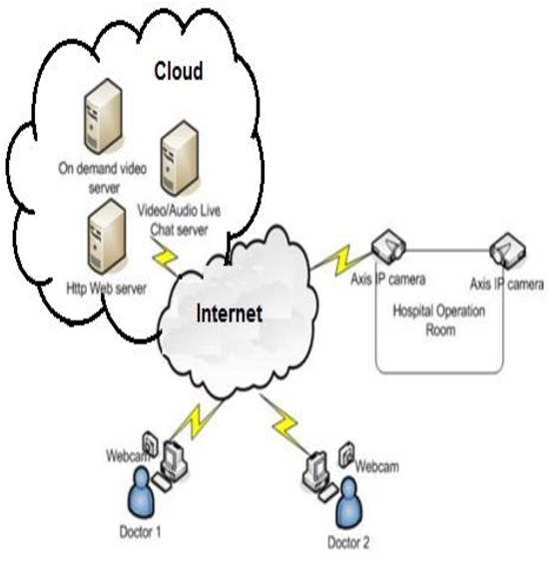

User Stories

User Story Table – Video Conferencing App
User Type | Functional Requirement (Epic) | User Story / Task | Acceptance Criteria | Priority | Release
User |  | As a user, I can sign up and log in securely. | User is authenticated and redirected to dashboard. | High | Sprint-1
  Authentication
Host |  | As a host, I can create and schedule a meeting. | Meeting ID/link is generated and visible on dashboard. | Medium | Sprint-2
  Meeting Creation
Participant | Join Meeting |  | User joins meeting successfully. | High | Sprint-1
  As a participant, I can join a meeting using a link or ID.
User | Audio & Video Control | As a user, I can enable or disable my audio and video. | Audio/video toggles work correctly. | High | Sprint-1
User | Messaging | As a user, I can chat with other participants in real-time. | Messages appear instantly for all participants. | Medium | Sprint-2
Host | Screen Sharing | As a host, I can share my screen during the meeting. | Screen is visible to all participants. | High | Sprint-2
Host |  | As a host, I can mute or remove participants. | Selected participant action is applied immediately. | High | Sprint-2
  Participant Management
User | Password Management | As a user, I can change my password. | Password updated successfully. | Medium | Sprint-2

